A noun is a naming word.
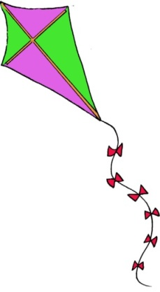
kite
A noun phrase also names something, but using more than one word.
a purple and green kite with a long tail

In the following sentence the noun phrase is underlined.
The old red car with a rusty bonnet broke down outside school.

If you are not sure if a group of words is a noun phrase or not, try replacing it with a pronoun. If it still makes sense then it is a noun phrase.
It broke down outside school.

Using a noun phrase can make writing more interesting than just using a noun on its own.

